Ex.No. : 3

Date:

**DML Commands – INSERT, SELECT, UPDATE, DELETE**

**Aim:**

To perform Data Manipulation Language (DML) Commands such as INSERT, SELECT, UPDATE, DELETE in the table.

**Description:**

Data Manipulation Language (DML) statements are used for managing data within schema objects. DML Commands: Insert , Update, Delete, Select

* + INSERT - insert data into a table 
  + UPDATE - updates existing data within a table 
* • DELETE - deletes all records from a table, the space for the records remain 
  + SELECT - retrieve data from the a database 

**INSERT**:

INSERT INTO table_name

VALUES (value1, value2, value3,...);

( or )

INSERT INTO table_name (column1, column2, column3,...)

VALUES (value1, value2, value3,...);

**UPDATE:**

UPDATE table_name

SET column1=value, column2=value2,...

WHERE some_column=some_value;

**DELETE:**

DELETE FROM table_name

WHERE some_column=some_value;

**SELECT:**

SELECT column_name(s)

FROM table_name;

**Questions**:

1. Populate all the five tables with your own data.
2. Update the value of student name whose register number is ‘191711342’
3. Delete the record in the table FACULTY, who resigned her job.
4. Modify the date of birth for the faculty whose name is 'RAM' with a value ‘1983-05-01’.
5. Remove all faculty who are having over 65 years
6. View all the records from the five tables. Exercise

**OUTPUTS:**

1) 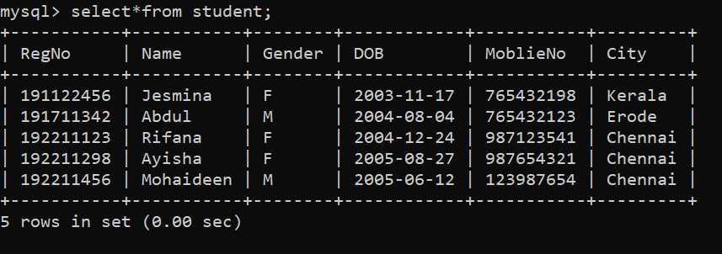

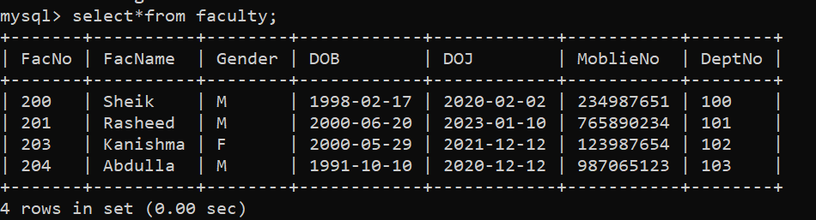

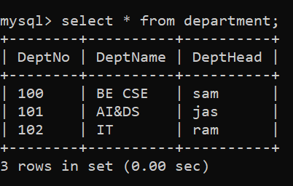

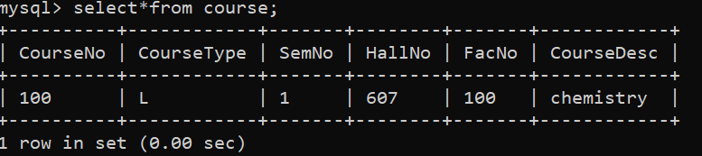

2)

3)

4)

5)

6)

**RESULT**:

Data Manipulation Language (DML) Commands such as INSERT, SELECT, UPDATE, DELETE are performed in the five tables.

16-DATABASE MANAGEMENT SYSTEMS